**Exercise**

* Modify the SecondRoute widget to display the image of the dice that was rolled in the main route. For example, if the main route shows a dic-3 image, the SecondRoute widget hould display the same image.
* Modify the SecondRoute widget to display the number of times the dice was rolled in the main route. For example, if the dice was rolled 5 times in the main route, the SecondRoute widget should display the number 5. 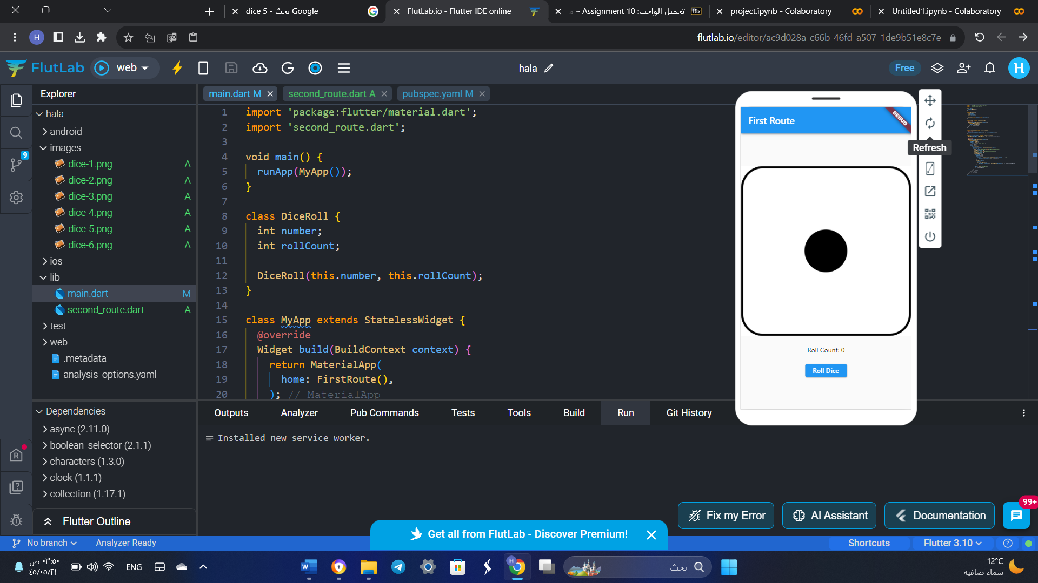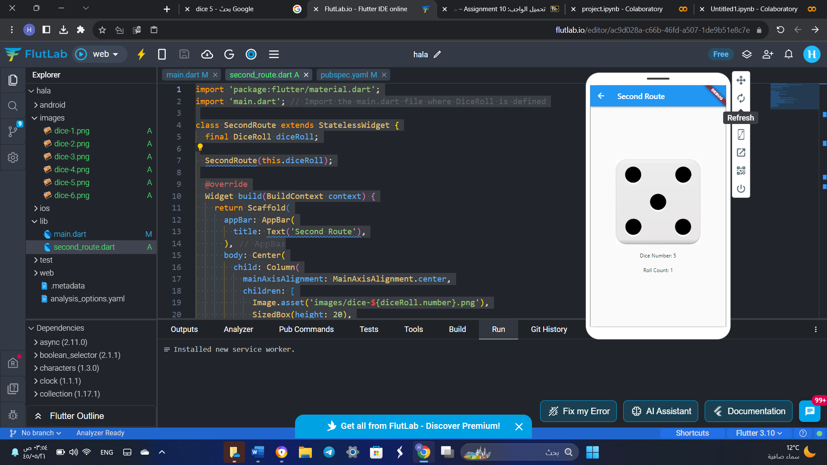

* import 'package:flutter/material.dart';
* import 'second_route.dart';
* void main() {
* runApp(MyApp());
* }
* class DiceRoll {
* int number;
* int rollCount;
* DiceRoll(this.number, this.rollCount);
* }
* class MyApp extends StatelessWidget {
* @override
* Widget build(BuildContext context) {
* return MaterialApp(
* home: FirstRoute(),
* );
* }
* }
* class FirstRoute extends StatefulWidget {
* @override
* _FirstRouteState createState() => _FirstRouteState();
* }
* class _FirstRouteState extends State<FirstRoute> {
* DiceRoll diceRoll = DiceRoll(1, 0); // Initialize diceRoll
* @override
* Widget build(BuildContext context) {
* return Scaffold(
* appBar: AppBar(
* title: Text('First Route'),
* ),
* body: Center(
* child: Column(
* mainAxisAlignment: MainAxisAlignment.center,
* children: [
* Image.asset('images/dice-${diceRoll.number}.png'),
* SizedBox(height: 20),
* Text('Roll Count: ${diceRoll.rollCount}'),
* SizedBox(height: 20),
* ElevatedButton(
* onPressed: () {
* setState(() {
* diceRoll = DiceRoll((1 + DateTime.now().second) % 6 + 1,
* diceRoll.rollCount + 1);
* });
* Navigator.push(
* context,
* MaterialPageRoute(
* builder: (context) => SecondRoute(diceRoll)),
* );
* },
* child: Text('Roll Dice'),
* ),
* ],
* ),
* ),
* );
* }
* }
* import 'package:flutter/material.dart';
* import 'main.dart'; // Import the main.dart file where DiceRoll is defined
* class SecondRoute extends StatelessWidget {
* final DiceRoll diceRoll;
* SecondRoute(this.diceRoll);
* @override
* Widget build(BuildContext context) {
* return Scaffold(
* appBar: AppBar(
* title: Text('Second Route'),
* ),
* body: Center(
* child: Column(
* mainAxisAlignment: MainAxisAlignment.center,
* children: [
* Image.asset('images/dice-${diceRoll.number}.png'),
* SizedBox(height: 20),
* Text('Dice Number: ${diceRoll.number}'),
* SizedBox(height: 20),
* Text('Roll Count: ${diceRoll.rollCount}'),
* ],
* ),
* ),
* );
* }

}